"WHAT YOUR FAMILY SHOULD KNOW"

Your Personal & Financial Diary

This is the personal diary of:

Social Security Number

This Diary was last updated on:

We strongly suggest you complete this diary and save it on your personal computer. We also suggest storing a printed and digital copy in a fire-resistant container in a secure location. We also recommend contacting and providing those V.I.P. with a copy of your wishes.
Acknowledgments

This document was developed in November 2005 and revised in 2024 to be used as an informational tool for members of the Houston Fire Department. The information contained in this document was designed to be used as a guide in assisting the family members in the event of a firefighter’s death.

This project was made possible with the help of Taking Care of Our Own, The Federation of Fire Chaplains, and the Chaplain’s Office of the Houston Fire Department.

“What Your Family Should Know” is a project of The Public Information Office of the Houston Fire Department. We thank everyone who participated and provided insight in this document for their support.

INTRODUCTION

This personal family and financial diary was planned to give firefighters who serve in a high-risk profession the opportunity to organize their personal and financial business. This information will help guide their families through a difficult time should firefighters be killed in the line of duty or die at an early age. However, anyone can use this diary to organize his or her personal and financial affairs.

Having worked with many families who have lost loved ones in the line of duty or as active members and retirees, it is apparent that some firefighters need assistance handling their personal paperwork. Firefighters seem more comfortable fighting fires than organizing their personal affairs. Each time we gather to honor a fallen firefighter, we are often confronted with more and more families whose loved ones have forgotten to update their beneficiary forms. This is a hurt no family should have to suffer. The information provided will eliminate many family traumas associated with the loss of a loved one.

PLEASE NOTE: This document is designed to serve as a tool to help you organize all your personal effects. The example “wills” are simply samples to guide you through the process. It is essential that you contact an attorney when you wish to finalize your wills and other legally binding documents.

Take time with your loved ones to complete Your Personal/Financial Diary. It will save you, or your survivors, hundreds of hours searching for personal and financial information. And remember to update your changes as needed.

If you are a firefighter, this is another way you can serve your family even in your absence and give them as much opportunity to grieve properly as possible.

Houston Fire Department
Public Information Office
500 Jefferson, Suite 1705
Houston, Texas 77002
713.495.7900

TABLE OF CONTENTS

MODULE ONE

6
7
8
11

13
14
14
15
15
15
16
16
17
17
17
18
18

20
21
32
32
32
34
35
36

39
41
44
45
46
48
49

IN CASE OF EMERGENCY……………………………………………………………………..
IMPORTANT PERSONAL & BUSINESS CONTACTS…………………………………………..
FAMILY PERSONAL HISTORY DOCUMENTS & INFORMATION……………………………
BENEFITS THROUGH EMPLOYMENT…………………………………………………………..

MODULE TWO
FINANCIAL BANK ACCOUNTS & INVESTMENTS…………………………………………….
MEDICAL & DISABLITY INSURANCE…………………………………………………………..
CREDIT CARDS…………………………………………………………………………………..
TAX RETURNS……………………………………………………………………………………..
MY PERSONAL BUSINESS VENTURES………………………………………………………….
REAL ESTATE…………………………………………………………………………….………..
TRUST FUNDS……………………………………………………………………………………..
PERSONAL DEBTORS & CREDITORS……………………………………………….………….
HOMEOWNER’S & MORTGAGE INSURANCE……………………………………..………..
AUTOMOBILES AND AUTO INSURANCE……………………………………………….…….
BOATS, TRAILERS, OR OTHER MOTORCRAFT…………………………………….…….……
OTHER INSURANCE………………………………………………………………..…………….
LOG-IN INFORMATION…………………………………………………………….…..……….

MODULE THREE
FINAL LIVING WILL………………………………………………………………………………
WILL PREPARATION……………………………………………………………………….…....
MY WILL…………………………………………………………………………….…….………
ORGAN DONATION……………………………………………………………………………
FUNERAL DETAILS……………………………………………………………………………….
SPECIAL FINAL REQUESTS……………………………………………………………………...
LIFE INSURANCE POLICIES……………………………………………………………….……
OTHER CONSIDERATIONS……………………………………………………………….…….

MODULE FOUR
RIGHTS OF SURVIVORSHIP…………………………………………………………………….
SAMPLE WILL…………………………………………………………………………….………
PERSONAL RECORD……………………………………………………………………………
AGENCY SHEET………………………………………………………………………………….
BENEFITS & FOUNDATIONS……………………………………………………………………
ADDITIONAL INFORMATION & COMMENTS……………………………………………….
FIREFIGHTER SUPPORT NETWORK BROCHURE………………………………………………

1
M O D U L E
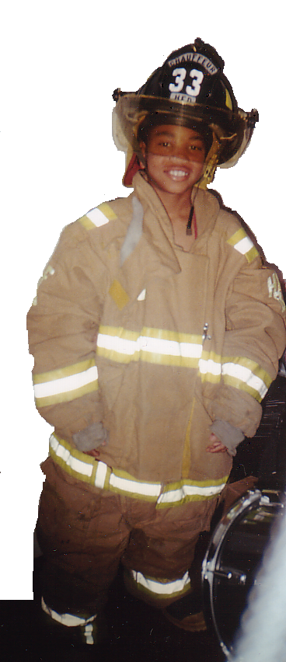
IN CASE OF EMERGENCY
Here in Module One, you will find information that deals with the immediate aftermath of a death. Contact names, both personal and business, can be listed in the first few pages of this module. The remaining pages concern your family history and information about the benefits you receive from your employer. Immediately after the death of a loved one, work must be done to contact the family members, friends, and business associates of the deceased.

In this module you will be able to document all the important contact information of these groups. To alleviate searching for your employment benefits paperwork, Module One also contains a log where you can chronicle your health care providers, dental, disability insurance and more for easy reference.

IMPORTANT PERSONAL &
BUSINESS CONTACTS

FAMILY PERSONAL HISTORY
DOCUMENTS & INFORMATION

BENEFITS THROUGH EMPLOYMENT

IN CASE OF EMERGENCY

THESE PEOPLE MUST BE NOTIFIED

Name: | Relationship:

Address:

Home Phone: |  | Work Phone:

Name: |  | Relationship:

Address:

Home Phone: |  | Work Phone:

Name: |  | Relationship:

Address:

Home Phone: |  | Work Phone:

Name: |  | Relationship:

Address:

Home Phone: |  | Work Phone:

Name: |  | Relationship:

Address:

Home Phone: |  | Work Phone:

Name: |  | Relationship:

Address:

Home Phone: |  | Work Phone:

Name: |  | Relationship:

Address:

Home Phone: |  | Work Phone:

IMPORTANT BUSINESS/PERSONAL CONTACTS

My Immediate Supervisor:
Employer:
Address:
Phone:

Spouse’s Immediate Supervisor:
Employer:
Address:
Phone:

Personal Physician:
Phone:

Clergyman:
Church Affiliation:
Phone:

Attorney:
Phone:

Dentist:
Phone:

Accountant:
Phone:

Insurance Agent:
Insurance Company:
Phone:

Banker:
Bank Name:
Phone:

Broker:
Investment Company:
Phone:

FAMILY PERSONAL HISTORY DOCUMENTS

Name: |  | Nickname:

My birth date:
My birth certificate is located at:
I was born in:
My Social Security Number is:
I was married in:
On: |  |  |  | To:
Children from this marriage:
I was divorced on: |  |  |  |  | State of:

I was married in:
On: |  |  | To:
Children from this marriage:

Marriage Certificate(s) are located at:
Divorce Decrees are located at:

Children’s birth certificates are located at:
Children’s adoption papers are located at:

Children’s Names | Date of Birth | Residence

I served in the Armed Forces: | Branch:
Service serial number:

Enlisted on: |  | At:
Discharge Date: |  | Discharge Papers located at:

Personal Information (Continued)
Husband’s relatives and addresses: (If deceased, indicate after their name)
Mother:
Address:
Father:
Address:
Sister:
Address:
Sister:
Address:
Brother:
Address:
Brother:
Address
Grandmother:
Address:
Grandmother:
Address:
Grandfather:
Address:
Grandfather:
Address:

Wife’s relatives and addresses: (If deceased, indicate after their name)
Mother:
Address:
Father:
Address:
Sister:
Address:
Sister:
Address:
Brother:
Address:
Brother:
Address:
Grandmother:
Address:
Grandmother:
Address:
Grandfather:
Address:
Grandfather:
Address:

Personal Information (Continued)

Grandchildren:

Name: | Date of Birth: | Their Parents:

People Who Have Special Meaning To Me:

BENEFITS THROUGH EMPLOYMENT

My Employer is:
Address:
Phone number of benefits division:
Benefits offered by my employer:
1. |  | 4.
2. |  | 5.
3. |  | 6.

Health Care Provider:
Phone: |  |  | Policy Number:

Dental Care Provider:
Phone: |  |  | Policy Number:

Eye Care Provider:
Phone: |  |  | Policy Number:

Disability Insurance Provider:
Phone: |  |  | Policy Number:

Files bearing employment documents are located at:

2
M O D U L E

The information contained in Module Two concerns the financial aspects of a death. The pages in this module will enable you to organize all your financial assets where they will be readily accessible when needed. As with all the information contained in this document, please remember to update your financial records as you make changes to them.
FINANCIAL BANK ACCOUNTS & INVESTMENTS

MEDICAL & DISABILITY INSURANCE

CREDIT CARDS

TAX RETURNS

MY PERSONAL BUSINESS VENTURES

REAL ESTATE

TRUST FUNDS

PERSONAL DEBTORS AND CREDITORS

HOMEOWNER’S & MORTGAGE INSURANCE

AUTOMOBILES & AUTO INSURANCE

BOATS, TRAILERS, OR OTHER MOTOR CRAFTS

OTHER INSURANCE

LOG-IN INFORMATION

FINANCIAL BANK ACCOUNTS &

INVESTMENTS HISTORY

Checking Account #: |  | Bank:

Signatories are:

Checkbooks are kept at:

Checking Account #: |  | Bank:

Signatories are:

Checkbooks are kept at:

Savings Account #: |  | Bank:

Signatories are:

Checkbooks are kept at:

Savings Account #: |  | Bank:

Signatories are:

Checkbooks are kept at:

Certificate of Deposit #: |  | Bank:

Signatories are:

Certificate is kept at:

Certificate of Deposit #: |  | Bank:

Signatories are:

Certificate is kept at:

Safe Deposit Box #: |  | Bank:

Safe deposit box is accessible to:

Key is kept at:

Investment/Stock Portfolio is located at:
Bonds Portfolio is located at:

IRA certificate and file is located at:
401(k) Retirement file is located at:
Pension (company-funded) file is located at:

MEDICAL AND DISABILITY INSURANCE

Medical Insurance is provided to me through my work. Yes No

This is the name of the office/person at my place of employment regarding medical insurance issues:
I have personally acquired medical insurance through the following companies:

Location of Policies:

You may need to talk with the State Worker’s Compensation office at:
Phone:

CREDIT CARDS

I have credit cards with the following companies:
Name | Account Number | Location of Statements | Insurance Provided?

TAX RETURNS

Copies of my income tax returns are located at:
Current withholding tax forms and receipts received from my employer are located at:

All worksheets and evidence in support of the returns are attached to the returns:
Yes No

Worksheets are located at:

MY PERSONAL BUSINESS VENTURES

I own or have an interest in (name of business):
Address:
In partnership/co-ownership with:
Address: |  |  |  | Phone:
The contract concerning the business arrangement is located at:
Percentage of my share of the business is:
Tax papers for the business are located at:

REAL ESTATE

My resident address is:

I own my residence: Yes No

My landlord is:
Ownership Title bears the names of:
The mortgage on the property is held by:
The mortgage payment records are located at:

The mortgage agreement carried life insurance coverage: Yes No

Homeowner’s insurance papers are located at:
The insurance broker is:
Tax paperwork on my residence is located at:

I own other real estate at (list addresses):

Deeds, mortgage information, tax documents, and payment records are located at:

TRUST FUNDS

I have established a living trust for the benefit of:
It was established on:
The trust agreement is located at:
The Trustees are:
The attorney who drew up the agreement is:
I am a beneficiary under a trust established by:
Papers are located at:
If I die, my heirs will be beneficiaries of trust funds established by:
Papers are located at:

PERSONAL DEBTORS AND CREDITORS

The following owes money to me:
Exclusive of secured loans, I owe money to the following:
I have the following loans covered by borrowers’ life insurance:
Copies of notes, loan agreements, and receipts are located at:

Are there any lawsuits you are involved in as the plaintiff or defendant?

Yes No

Name of Attorney: |  | Phone:

HOMEOWNER’S AND MORTGAGE INSURANCE

Company Contact Phone Location of Paperwork

Agent’s Name: |  | Phone:

AUTOMOBILES AND AUTO INSURANCE

Make Model Year Registered to Status of Ownership

Company name of auto insurer:

Agent’s Name: |  | Phone:

BOATS, TRAILERS, OR OTHER MOTOR CRAFTS

Make Model Year Registered to Status of Ownership

OTHER INSURANCE

Credit cards, credit unions, travel agencies, etc. often carry insurance policies on clients. List various sources that provide this benefit:

LOG-IN INFORMATION

Platform | Username/Email or Phone Number | Password | Security Answers

MODULE THREE

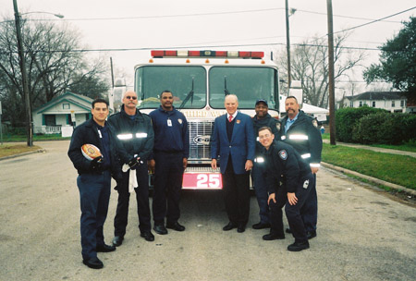
3
M O D U L E
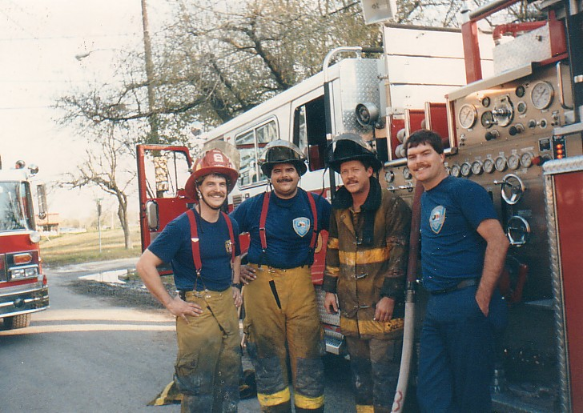
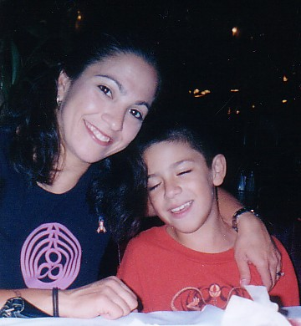
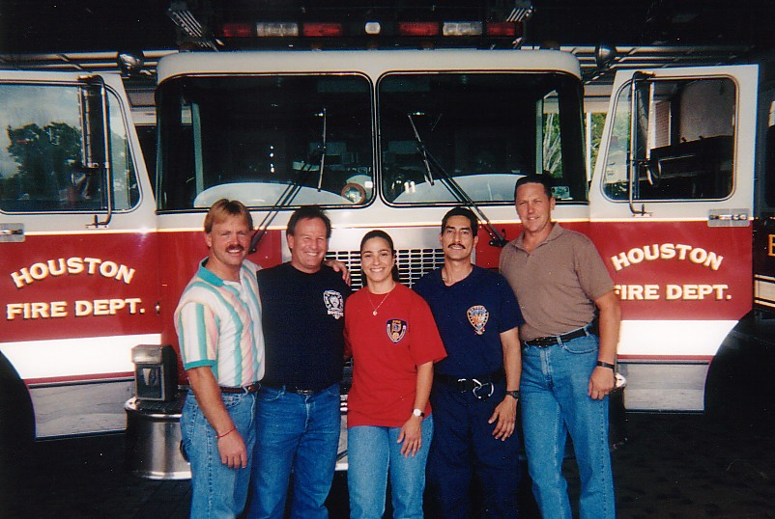

FINAL LIVING WILL
Module Three will help you organize your final wishes regarding your will, life insurance, organ donation and funeral details. Only you can answer questions like, “Do I want to be kept alive on a life support machine?” This module contains information that will help you create a living will so that your final wishes will be satisfied. It is essential to provide your family with this important information to help ease their burden during this difficult time.

WILL PREPARATION

MY WILL

ORGAN DONATION

FUNERAL DETAILS

SPECIAL FINAL REQUESTS

LIFE INSURANCE POLICIES

OTHER CONSIDERATIONS

It is important that you contact an attorney when you wish to finalize your wills and other legally binding documents.

MY FINAL LIVING WILL & FUNERAL PLANNING

Individuals may execute a “living will” that instructs family members and physicians not to take extraordinary steps to continue their lives on life-support machines. You should investigate the legality of the “living will” within your state and take steps to execute the “living will” if you do not choose to be kept alive through mechanical means.

I have not executed a “living will.”

I have executed a “living will.”

Since copies of living wills may not be acceptable in some states, an original, signed copy of my living will is readily accessible at:

Additional copies of my “living will” are on file with my physician, attorney, and with my will.

WILL PREPARATION

The following is a list of topics and questions you should consider. Some questions may not apply to you, your testamentary desires, or your circumstances. If you wish to appoint any persons to positions of responsibility in your organization, you will provide their complete names, addresses, and relationships to you. Remember! It is imperative to consult an attorney to finalize your wills and other legally binding documents!

A: NAME OF TESTATOR

- Are you known by any other name? Yes No If yes, list them.

- Have you used other names in the past? Yes No If yes, list them.

- If a name change has occurred, are the legal papers in order? Yes No Details?

B: DOMICILE

- Do you own or maintain a residence outside the state of Texas? Yes No

- Should a definitive statement be made in the will as to your intent regarding domicile or residence? Yes No If yes, please include your instructions regarding this residence.

Details:

- What is your residence address?

C: AGE

- Do the dates on birth certificates and insurance policies coincide? Yes No

D: FAMILY

- Are you: Married Single Widow Widower Adopted

- Any previous marriages? Yes No Did it end by death or divorce? Death Divorce
Death Divorce

Please provide the name of the prior spouse and the date of dissolution of marriage.

Name: |  | Date:
Name: |  | Date:

- What are your children's full names, addresses, birth dates, and marital status?
Name Address Birth Date Marital Status

- Are there any adopted children? Yes No
Name:
Name:
Name:
Name:

- Are there any deceased children? Yes No
Name: |  | Date of Death:
Name: |  | Date of Death:
Name: |  | Date of Death:
Name: |  | Date of Death:

Name:
Name:
Name:
Name:
- Do you intend to disinherit any of your children? Yes No

- Are any provisions to be made for children born after your death? Yes No
Name: |  | Detail:
Name: |  | Detail:
Name: |  | Detail:
Name: |  | Detail:

- Are any provisions to be made for individuals who claim to be your children? Yes No
Details:

- Have advancements been made to any of the children? Yes No If so, are they to be deducted from the gifts to the children? Yes No

Details:

- Are your parents living? Yes No Do you want to provide for them? Yes No

Details:

- Do you want to provide for any grandchildren? Yes No

Details:

- Do you want to provide for any other relatives? Yes No

Details:

E: GUARDIAN
Co/individual guardians may be named.

- Do you want a guardian to be appointed for your minor or incapacitated children? Yes No If so, who shall be appointed? Any alternatives? Provide their full names and current addresses.

Name: |  | Address:

- Is the guardian required to give bond? Yes No
Details:

- What specific provision, if any, should be made for the support/rearing of your children? E.g., Their education?

Details:

F: FUNERAL INSTRUCTIONS

- Do you have a preference as to how your body should be disposed of? Yes No
Details:

- Are any provisions regarding cemetery lot, tombstone, and upkeep of the cemetery lot to be provided for in the will? Yes No
Details:

G: PRIOR WILLS AND CODICILS

- Do you have copies of prior wills and codicils? Yes No

- Are all prior wills and codicils to be revoked? Yes No

- Have you made provisions to destroy any prior wills? Yes No

Details:

H: DEBTS

- Do you have any existing debts? Yes No If so, describe them on a separate sheet of paper.

- Do you have any liability, such as surety on a bond, pledge to any charity or the like, etc.? Yes No

Details:

- Are debts to be paid from any specific property? Yes No

Details:

- What property is mortgaged or has other liens?

Details:

- Is mortgage or lien to be paid by the person or persons who receive your property, from the general estate or from a particular fund? Yes No
Details:

- What property is to be sold first to pay any debts of the estate?

Details:

- If a gift is made to a creditor, is it to be in payment of your indebtedness or in addition thereto?
Yes No

Details:

I: DEBTS OWED TO YOU

- Are any debts to be canceled? Yes No

Details:

- Are special provisions to be made for their payment? Yes No

Details:

- If a legacy is given to one who is indebted to you, is the debt to be deducted from that legacy?
Yes No

Details:

J: HUSBAND AND WIFE

- Was a prenuptial or community property agreement made? Yes No

- Are gifts to be in lieu of dower or curtesy? Yes No

Details:

- Are gifts to stop if the surviving spouse remarries? Yes No

Details:

- Are family living expenses to be provided during the period of time when the estate is being settled? Yes No

Details:

K: PROPERTY OWNED BY YOU

- Is there any property in your name that belongs to someone else? Yes No

Details:

- What is to be done with your property that is held as an agent or trustee for another?

Details:

- What property is to be expressly given and to whom? E.g., items of sentimental value or otherwise.

Details:

- Have you created any living trust? Yes No

Details:

- Have you any future or contingent interest? Yes No If so, how is it to be disposed of?

Details:

REAL PROPERTY

- What real property do you own? You will need an address and a copy of the deed if one is available.
Details:

b. Is the property owned in fee simple? Yes No

c. Has any real property been bought or sold on contract for deed? Yes No

d. Is any of this property mortgaged? Yes No
Details:

e. If mortgaged, is the devise to be subject to the mortgage? Yes No
Details:

f. Is there any real property located outside the state where you live? Yes No
Details:

g. What real property is to be specifically devised and to whom?
Details:

h. In whose name is the title to your family home?
Name:

- What is the legal description of any real property owned by you? (Provide a copy of the deed.)
Details:

PERSONAL PROPERTY

- What monetary gifts, if any, are to be made and to whom?
Details:

- How are personal effects to be disposed of?
Details:

- Are any stocks, bonds, or mortgages to be specifically bequeathed? To whom?

Name: |  | Item:
Name: |  | Item:
Name: |  | Item:
Name: |  | Item:

PARTNERSHIP PROPERTY

- Are you a member of any partnership? Yes No

Details:

b. Are there articles of partnership? Yes No If so, provide copies of them.

c. What provision is to be made as to the disposition of the interest in the partner and partnership?

Details:

L: RESIDUARY CLAUSE

- What shall be done with the balance of the estate after all bequests have been paid or specifically devised? E.g., are items to go into a trust or divided equally between children or given only to your spouse?
Details:

M: TRUSTS
Co/individual trustees may be named.

- Is any of your property to be left in trust? Yes No E.g., to children?

Details:

- Who is to be appointed trustee? Successor trustee? Provide their full names & addresses.

Name: |  | Address:

- What is to be done if the trustee dies, resigns, or is unable to act?

Details:

- Who will be the beneficiaries of the trust and how is income to be paid to them, and how is the principal to be distributed? (For instance, many parents wish their children to receive money from the trust for necessary living expenses and emergencies; however, the balance would not pay to them until they reach a certain age, such as 25. Again, some parents would prefer a “sprinkling trust” which would distributes to their children at different ages: e.g., 1/3 at 22 and remainder at 25. Again, some parents like to dangle a “carrot” in front of their children as an incentive for graduation. E.g., “1/3 of trust to child at 24 but that share can be paid out prior to this if they have earned a bachelor’s degree at an accredited educational institution.”

Details:

- May trust funds be used to remodel guardian’s home to accommodate your children?
Yes No

Details:

- Are there any special provisions regarding your children's education? Yes No

Details:

- At what age will the children receive the trust principal?

Details:

- Would you like to “sprinkle” the trust principal or pay it all in one lump sum? Yes No
Details:

N: CONDITIONAL GIFTS

- Are any gifts to be conditional? Yes No

Details:

- Are any provisions to be made for disinheriting persons who may contest the will? Yes No

Details:

O: CHARITIES

- What gifts, if any, are to be given to charities?

Details:

- What gifts, if any, are to be given to servants, employees, or other people?

Details:

P: EXECUTOR
The Executor is the person who will manage your estate until all debts are paid, property dispersed, and final approval has been given by the court to close your estate. Co or individual executors may be named.

- Who is to be the executor? Alternate Executor. What are their full names and addresses?

Name: |  | Address:

- Are provisions made if the executor decides or refuses to act as such? Yes No

Details:

- Will the executor be required to give bond? Yes No

Details:

- Do you wish to give your Executor a maximum amount of freedom to handle your estate, or would you like a maximum amount of court supervision?

Details:

Q: NON-TESTAMENTARY TRANSFERS.

- Which items, if any, would you like to pass automatically to your survivors without the need of having that item pass through probate proceedings? These types of transfers would need to be expressed in another document such as a living trust or a community property agreement. Please consult an attorney for the details of these documents.

HAVE YOU THOUGHT ABOUT HOW YOUR AFFAIRS WILL BE HANDLED IF YOU ARE EVER INCAPACITATED? CONSIDER THE FOLLOWING:

1. DURABLE POWER OF ATTORNEY. Appoints the person of your choice to manage your financial affairs in the event you are incapacitated.

2. DURABLE POWER OF ATTORNEY FOR HEALTH CARE. Appoints the person of your choice to make your medical decisions in the event you are incapacitated.

3. PRE-NAMING A GUARDIAN FOR YOURSELF OR YOUR CHILDREN IN THE EVENT OF YOUR INCAPACITATION.

4. LIVING WILL (DIRECTIVE TO PHYSICIANS). Grants permission to doctors and medical facilities to end life support in the event you cannot survive other than through artificial means. These are often helpful to families because this hard choice will not have to be made by them if you do so in advance. In addition, this may help to reduce unnecessary, and costly medical bills that will be billed to your estate in the event of your death.

5. HIPAA RELEASE FORM. The HIPAA Release form is a new form that most estate planning attorneys are now drafting for their clients for the Health Insurance Portability and Accountability Act of 1996. It created medical privacy laws that require health care providers to be careful how they release protected health care information. When you check in to a hospital or see a doctor you can sign the necessary forms, but in an emergency, you may not be able to sign the necessary forms and you want to sign the HIPAA Release form in advance.

MY WILL

Your will should address special requests on how you would like insurance money to be spent, who you would like to have your prized possessions, etc. By providing this information in a will, your wishes can be upheld in court. Otherwise, your primary beneficiary will have total control of your assets/possessions. However, if this information is not included in your will, there is a section in this handbook for that information to be provided.

I do not have a will. . (Often times, families incur additional emotional, legal and financial burdens when a loved one dies without having executed a will. We strongly suggest this be a task that you address as soon as possible.)

I have a will and it is located at:

I have a will and it is located at:
The attorney who handled my will is:
With the firm:
Phone number:
My will is last dated:
The Executor is:

ORGAN DONATION

I do not want any of my organs donated.

I would like to have organs donated for transplant.

I would like to donate the following organs for transplant/research:

FUNERAL DETAILS

Church preference:
Religious affiliation:
Clergyman:
Phone:
Funeral home to be used:
Phone:

I have a pre-paid burial plan. Yes No

Contact:

(Some funeral homes provide free burial services to a firefighters killed in the line of duty. Check on this benefit through your agency.)

Service to be held at:
Funeral home:
Name of funeral home:
Church:
Name of Church:

I prefer: Interment Entombment Cremation

My choice of cemetery:

I have purchased a lot. I have not purchased a lot.

Lot is in the name of:
Section: |  |  |  | Lot: |  | Block:
Location of deed for lot:

If interment is in another city, give information on the receiving funeral home:

Name: |  |  | Phone:
Address:

Pallbearers:

If cremated, what do you wish done with your ashes?

Obituary: Yes No

Please list the following in my obituary:

I am entitled to Veterans Benefits: Yes No
I am entitled to Military Honors: Yes No
I would like a “Lodge” service: Yes No
By:

Disposal of flowers:
Flowers: Yes No

Donations in lieu of flowers to:

Musical selections:

Special requests for service:

SPECIAL FINAL REQUESTS

As noted earlier in this compact disc, special final requests should be addressed in one’s will so your wishes will be upheld by a court of law. If you have not addressed these special final requests in a will, your primary beneficiary will have total control of your assets/possessions for final disposal. We strongly recommend addressing these issues in your will. If you choose not to, however, complete this section to alleviate your family of the decisions that might need to be made on your behalf.

This is how I would like insurance settlement money to be spent:

This is how I would like real estate to be handled:

This is how I would hope my family would continue/improve their relationships:

These are my prized possessions and how I would like them to be distributed:
Item Given to

I would like my clothing and other general personal effects distributed in this manner:

Other special wishes:

LIFE INSURANCE POLICIES

To ensure easy access to actual policies, beneficiaries, etc., all policies owned should be kept together in a safe place. Premium receipts, loan information, and settlement agreements on these policies should also be filed with the policy.

Location of policies:

I have made loans against the following policies:

I also own annuity contracts: Yes No

Location of contacts:

My principal life insurance advisor is listed in “Important Business/Personal Contacts”.

Other insurance advisors include:

Name: |  | Company:
Phone:

Name: |  | Company:
Phone:

I also belong to the various social/fraternal organizations that carry insurance for their membership:

Organization: |  | Contact:
Address: |  | Phone:

Organization: |  | Contact:
Address: |  | Phone:

Organization: |  | Contact:
Address: |  | Phone:

Organization: |  | Contact:
Address: |  | Phone:

OTHER CONSIDERATIONS

The death of a loved one is always traumatic and painful. When a firefighter is killed in the line of duty, firefighters and citizens throughout the nation mourn with the family. Texas firefighters have joined together to extend sympathy, comfort, and aid to the families of their fallen comrades.
Help in getting benefits to which family members are entitled is very important. The number of documents necessary to get benefits varies because of different requirements among the federal, state, local, and private agencies. Generally, the following numbers of documents are sufficient.

Death certificate 25-35
Marriage certificate 5
Birth certificate for children 5
Employer’s affidavit of employment 12
Investigation report 5
Complete autopsy 5
Toxicology report 5
Divorce decree for previous marriages 5
Newspaper account of incident 5
Emergency room/ hospital record 1
Birth certificate of decease 1
Witness’ affidavits As Required
When the surviving spouse is a female, she will need a certificate from a licensed physician stating whether she is pregnant. This statement will protect the rights of an unborn child who may be eligible for benefits.
Each claim for benefits will require documentation to support the claim. Each document must be an original or a copy certified by the agency from which it comes.
If an official seal of the agency does not accompany the signature of the certifying official, the signature of the official must be notarized. A notary public signature and seal alone are not sufficient to certify a document. Agencies administering benefits normally won’t accept photocopies of documents that don’t have proper seals or signatures.
If a statement by an individual is required to support a claim, it should be an affidavit that is signed and notarized.

The benefits from various federal agencies tend to be consistent from year to year since they are available to firefighters across the nation. The state agencies in Texas are very consistent from year to year and tend to correlate very well with awards from federal agencies. Local benefits from county and city governments and from private organizations vary greatly from locale to locale. These differences exist in both procedures and amounts of the benefits given. The private organizations that award benefits on a state basis tend to be consistent and faster in their processes than their government counterparts.

This document was planned to save as much heartache as possible immediately following the
death of a loved one. All the planning and preparation in the world, however, won’t save a family serious heartache if someone chooses to keep information about their life from family members. Often after someone dies, family members are shocked to find out there are other children from outside the marriage and other significant others.

To save your spouse or other family members this heartache and torment, it is suggested that you write a letter to be opened upon your death that will tell your family about the issues you felt you could not discuss with them during your lifetime. Additionally, it is recommended that you discuss with your spouse the beneficiary listings you have chosen on various insurance policies. This will help alleviate the family upheavals that seriously affect the grief process when family members doubt that you meant to leave benefits to the people who received those benefits.

Be proactive and address these issues before you die, so you do not leave the decisions to someone who may not know what you would desire to happen.

Take the time to prepare a will, it is the only way to direct your estate and in turn will benefit the needs of your family.

4
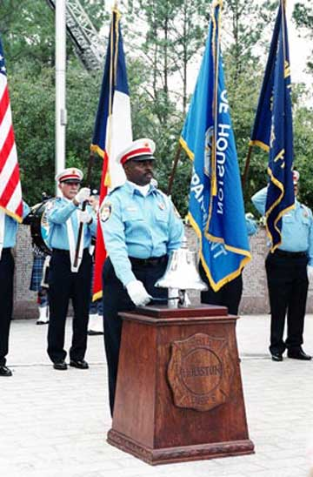
M O D U L E

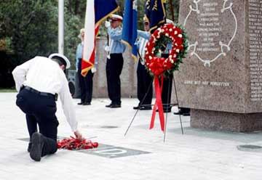
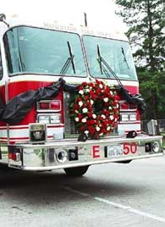

Module Four, the last module of this document, contains the remaining forms and information needed to complete this process.

A sample will can be found beginning on page forty-one as well as information regarding the rights of survivorship. Module four also contains information for such foundations like the 100 Club and the Houston Firefighters Union Local 341 and can be found on the BENEFITS & FOUNDATIONS LIST.

The time is now to prepare for the security of your loved ones. After all, if you don’t take care of your family…who will?
RIGHTS OF SURVIVORSHIP

SAMPLE WILL

PERSONAL RECORD

AGENCY SHEET

BENEFITS & FOUNDATIONS

SERVICE PROVIDERS

Agreement TO Establish Right Of Survivorship To Community Property Between Spouses

(At the November 3, 1987, General Election, Article XVI, Section 15, of the Texas Constitution was amended to allow spouses to agree in writing that all or part of their community property shall pass on the death of a spouse, to the surviving spouse. This form is intended for that purpose.)

Agreement
This Agreement is made between.
(herein referred to as “Husband”), and
(herein referred to as “Wife”) who reside at

County, Texas

Article I – Statement Of Facts Husband And Wife To The Following:

- Marriage – the parties married on the day of

(year)
- Community Property – The parties agree that the following is held as their community property.

2.1- Home and other real property located at:

2.2- All household furnishings of said home, all automobiles.

  - All bank accounts, certificates of deposit, and other property jointly owned, including the following:

  - All other property acquired during our marriage, except property acquired by gift or inheritance, clearly identified as separate property, and kept separate and apart from the community property of Husband and Wife.

Article II – Title On Death Of Spouse

- It is agreed that title to all community property of Husband and Wife, specifically identified herein or held as community property shall pass to the surviving spouse upon the death of the first of us to die, without the necessity of probate court proceedings or other legal action other than the recording of this Agreement in the records of the County Clerk of
County.

- This Agreement is conditioned upon our marriage continuing during the lifetime of both Husband and Wife. In case of divorce, this Agreement shall have no force and effect.

Executed this |  | day of |  | 20

____________________________________ _________________________________________
Husband Wife

State of Texas :
County of:

Before me, the undersigned authority, personally appeared.

__________________________________ and _________________________________,
known to me to be the persons whose names are subscribed to the foregoing instrument, and each oath acknowledged that they executed that they executed the foregoing instrument for the purposes and consideration therein expressed.

Subscribed and sworn to on this ___________ day of __________________, 20______.

____________________________________
Notary Public, State of Texas

____________________________________
(Print or type name)

My Commission expires_________________

Sample Will

THE STATE OF TEXAS:

KNOW ALL MEN BY THESE PRESENT:
COUNTY OF HARRIS:

That I, of Houston, Harris County, Texas, being of sound mind and disposing memory, do hereby make and publish this my last will and testament, hereby revoking all other wills and codicils heretofore made by me.

I

In this will I am undertaking to dispose of my separate property and my undivided one-half (1/2) of the community property of myself and my wife,
and the terms “my estate” or “my property” when used in this will shall be construed as referring only top my separate property or my one-half (1/2) of the community property.

II

I direct that all my just debts be paid out of my Independent Executrix, hereinafter appointed as soon as it is practicable for her so to do.

III

I devise and bequeath all of my property, whether real, personal or mixed, whenever located, that I may die seized or possessed of, or own an interest in, to pass and vest in fee simple in my wife, , for her sole and exclusive use and benefit.

IV

In the event my wife,
does not survive me, I hereby devise and bequeath all my property, whether real, persona; or mixed, whenever located, that I may die seized or possessed of, or own an interest in, to pass and vest in fee simple to my children,
share and share alike.

V

If to me any child or children shall be born of my wife or shall be adopted by me subsequent to the execution of this will, each such after born or adopted child is hereby mentioned and provided for as follows: It is my will that each of them shall receive nothing if my wife,
survives me; if my said wife does not survive me, each after-born or adopted child shall share equally with my children,
Neither my will not any part thereof shall be, because of such after born or adoption, revoked; or shall my will or my estate be in any manner affected thereby, except as above provided.

VI

I do hereby appoint my wife,
as Independent Executrix of my will, and I direct that no bond shall be required of her and that no other action shall be had in the County Court in relation to the settlement of my estate, other than the recording of this my will and the return of an inventory and appraisement and list of claims of said estate.

VII

It is my will that my said Independent Executrix shall have all the powers over my estate and its properties I would have if living and, without limiting the generality of the foregoing, I specially direct that she shall have the power to buy, sell, convey, mortgage, hypothecate or lease, and properties which may be a part of my estate at the time of my death, and to operate any business which may a part of my estate at the time of my death, and exercise all of the rights of a stockholder in any corporation, stock of which may be owned by me at the time of my death, all on any terms that may seem best to her.

IN TESTIMONY WHEREOF, I have hereunto signed my name in the presence of __________________________________, and ______________________________, as subscribing witnesses, each of whom signed this will at my request, in my presence of each other, this the _______ day of __________________, A. D., 20_____.

_____________________________________
Testator
WE, ____________________________, and_________________________, do hereby declare that the foregoing instrument, consisting of two (2) typewritten pages, including this page, was on the _______ day of __________________, 20______, signed, published and declared by _____________________________________. Testator named herein, as and for his last will and testament, in the presence of us, the undersigned, who, at his request and in the presence of him, and in the presence of each other, have first been read to us and we are now intending to certify that the matters herein specified took place in fact and in the order herein stated.

________________________________________
Witness

________________________________________
Witness

________________________________________
Witness

THE STATE OF TEXAS:

COUNTY OF HARRIS:

BEFORE ME, the undersigned authority, on this day personally appeared _____________________________________, ____________________________, and _____________________________________, known to me to be the testator and the witnesses, respectively, whose names are subscribed to the annexed or foregoing instrument in their respective capacities, and, all of said persons being by me duly sworn, the said ________________________________, testator, declared to me and to the said witnesses in my presence that said instrument is his last will and testament, and that he had willingly made and executed it as his free act and deed for the purposes therein expressed: and the said witnesses, each on his oath stated to me, in the presence and hearing of the said testator, that the testator had declared to them that said instrument is his last will and testament, and that he executed same as such and wanted each of them to sign it as a witness; and upon their oaths each witness stated further that they did sign the same as witnesses in the presence of the said testator and at his request: that he was at that time nineteen years of age or over and was of sound mind: and that each of said witnesses was then at least fourteen years of age.

____________________________________
Testator

____________________________________
Witness

____________________________________
Witness

Subscribed and acknowledged before me by the said _________________________, testator, and subscribed and sworn to before me by the said _________________________________, and ________________________________, witnesses, this ________ day of ____________________, A.D., 20_____.

________________________________________
Notary Public in and for Harris County Texas

Personal Record

Date this record was last revised:

Location Of Important Documents

1. | Adoption papers
2. | Automobile titles
3 | Bank passbooks
4. | Birth certificates
5. | Business agreements
6. | Deeds, mortgages, etc.
7. | Cemetery plot title
8. | IRAs, money markets, certificates of deposits etc.
9. | Insurance policies
10. | Marriage certificates
11. | Military serial # and evidence of service
12. | Lease agreements
13. | Naturalization papers
14. | Notes & obligations
15. | Safe-deposit boxes
16. | Safe-deposit boxes
17. | Securities (stocks& bonds)
18. | Social security number & records
19. | Tax returns for prior years & receipts
20. | Pension & retirement benefits data
21. | Trust fund records
22. | Veterans’ Administration claim number
23. | Will
24. | Other

AGENCY SHEET

If the person completing this booklet is a firefighter, this page can be completed and filed in your personnel file.

Employee’s name:
(Last) (First) (Badge/ID Number)

Social security number: |  | Date of birth:

In case of death or serious injury, have a department representative contact:

Name Day Address Evening Address Phone

Spouse:
Mother:
Father:
Closest relative:
Former spouse(s):

My best friend in the department is
and I would like him (her) to accompany anyone sent to give injury/death notice to my family. My best friend’s address is:
Phone number:

I want to serve as the liaison officer with my family.

The following members of my family have health concerns that the department should be aware of:

My family is aware of the beneficiaries listed on all my department insurance forms.
Yes No
I have a letter written to my family explaining why I have named certain beneficiaries on my policies. Yes No

I would like full Fire Department honors if killed in the line of duty. Yes No

Suggested pallbearers:

BENEFITS & FOUNDATIONS LIST

City of Houston INSURANCE BENEFITS
Contact: Human Resource
611 Walker, 4th floor, Houston, Texas 77002
Phone: (832)393-6000
E-Mail: benefits@houstontx.gov
E-Mail: retireebenefits@houstontx.gov
Website: https://www.houstontx.gov/hr/benefits.html

Houston Firefighters’ Relief and Retirement Fund- Pension Office
Contact: Member Services
4225 Interwood North Parkway, Houston, Texas 77032-3866
Phone: (281) 372-5100
E-Mail: memberservices@hfrrf.org
Website: https://www.hfrrf.org/

HOUSTON FIREFIGHTER LOCAL 341
Contact: Heather McBee for Relative Assistance or Insurance Questions
The Houston Professional Fire Fighters Association
International Association of Fire Fighters - Local 341
1907 Freeman Street, Houston, Texas 77009
Phone: (713) 223-9166 or 1-800-845-FIRE (3473)
E-mail: hpffa@local341.org
TEXAS WORKERS’ COMPENSATION
Contact: Texas Workers’ Compensation
507 North Sam Houston Parkway East, Suite 600, Houston, TX 77060
Phone: (281) 260-3035, (512) 804-4100 or (512) 804-4636
Website: https://www.tdi.texas.gov/wc/index.html

TEXAS CRIME VICTIM’S COMPENSATION
Contact: Crime Victim Services Division - CVC Program
Office of the Attorney General
PO Box 12198, Austin, TX 78711-2198
Phone: 1 (800) 983-9933 or (512) 936-1200 (in Austin)
E-Mail: crimevictims@oag.state.tx.us
Website:https://www.texasattorneygeneral.gov/crime-victims/crime-victims-compensation-program

SOCIAL SECURITY ADMINISTRATION SURVIVOR’S BENEFITS
Contact: Social Security Survivor’s Benefits Department
8989 Lakes at 610 Drive (SE), Houston, TX 77054
Phone: 1-800-772-1213 between 7 a.m. and 7 p.m., Monday through Friday.
Website: www.socialsecurity.gov

UNITED STATES DEPARTMENT OF JUSTICE
PUBLIC SAFETY OFFICERS’ BENEFITS ACT
Contact: Public Safety Officers' Benefits Program
Bureau of Justice Administration
633 Indiana Avenue, NW, Washington, DC 20531
Phone: 1-888-744-6513
E-Mail: AskPSOB@usdoj.gov
Website: https://bja.ojp.gov/program/psob

FLEETWOOD MEMORIAL FOUNDATION
Contact: Susan Van Meter-Community Impact Grants Coordinator
501 South Fielder Road, Arlington, Texas 76013
Phone: (817) 877-0702
E-Mail: CONNECT@NORTHTEXASCF.ORG
Website: https://northtexascf.org/nonprofits/first-responders/

THE 100 CLUB OF HOUSTON
Contact: The 100 Club, Inc.
6919 PortWest Dr. #150, Houton, Texas 77024
Phone: 713-952-0100 or 1-877-955-0100
Website: https://the100club.org/

DEPARTMENT OF VETERAN’S AFFAIRS VETERAN’S BENEFITS
Contact: Department of Veteran's Affairs
1722 I St NW, Washington, DC 20421
Phone: (800) 827-1000 or (800)698-2411
Website: https://benefits.va.gov/benefits/,
Website: www.va.gov

ADDITIONAL INFORMATION OR COMMENTS

If there is any additional information you want to provide that was not covered, please enter that information here.

FIREFIGHTER SUPPORT NETWORK BROCHURE

