2013

E104411
City of Houston

SMART GOAL OVERVIEW & TEMPLATE BUILDER FOR SUPERVISORS & MANAGERS

Table of Contents

SMART GOALS? WHAT? 3
Out with the Old… 4
1. Lacks definition as to what extra duties in support of the department really means 5
2. Category is based on Leadership & Thinking Skills 5
3. Failure to comply with (whatever number of infractions leading to lower score) 6
4. Lacks an ‘Unacceptable’ scoring measurement 6
In with the New… 7
The strengths of HEAR include transparency, simplicity, and accountability 8
A common question 12
SMART GOAL WORKSHEET 15
SMART GOAL WORKSHEET- EXAMPLE 16
RATING CRITERIA WORKSHEET- EXAMPLE 17

SMART Goals? What?

SMART GOALS? WHAT?
As the City of Houston began the transition from “the old way of doing things”, aka EPEs, city employees from the mayor on down to the general workforce have been introduced to the concept or practice of utilizing ‘SMART Goals’. SMART (in its City of Houston application) is an acronym for Specific, Measurable, Achievable, Relevant, and, Time-based (or bound).
SMART Goals are not a new concept or practice, but are an entirely new approach for the City of Houston in accomplishing its business goals. For the city, though, they really are much more than that. SMART Goals are the new and desired way for supervisors and managers to effectively communicate to their employees what is expected of them. For example, it is not enough for a manager to simply state to an employee, “get to work”, or “you know what to do, go do it”. How can statements such as those be accurately measured? More importantly, how can statements such as those be effective in communicating to employees what is expected of them? How can employees accomplish anything or grow in a position if there is no clear communication to them of what they are supposed to do for their supervisor or manager?
The next module of training is designed to take the learner from their current or former mindset as it relates to communicating with employees and bring you into a new mindset that will help you create effective SMART Goals for your employees. More on SMART Goals later … first, let’s take a look at the how the need for them came about.

Out with the Old…
The City of Houston formerly utilized a program called Performance Impact. This program served the city for over six years and was recently replaced by the new HEAR Interim Application. While the previous program had its fans and served its purpose, the reality of it was that it allowed for the perpetuation of flawed practices relating to employee goal setting, expectations of the same, and inevitably, employee evaluations. With the ‘old way of doing things’, it would be easy, and often times common, for workloads to be unbalanced between employees. The inequality relating to work loads, and in particular work completion, led to employees sometimes doing more than ‘their share’ or things that were not necessarily ‘part of their job description’…
Consider this example taken from an actual EPE from the former Performance Impact program:
Job Duty
Section Weight: 50%

Extra duties in direct support of the department
Due date:
Weight: 16%
Category: Leadership and Systems Thinking Skills
Description: Performs extra duties as assigned in support of the department
Measurement: Outstanding: Failure to comply with job function no more than one time
Strong: Failure to comply with job function no more than 2-3 times
Acceptable: Failure to comply with job function 4-5 times
Needs Improvement: Failure to comply with job function more than 5 times

This serves as a perfect example for confusion on the part of the employee, and also as an example of the lack of communication that previously developed and existed as a result of Performance Impact. This example ‘work plan’ was actually given to the employee in April, 2012. The employee was expected to adhere to the plan with little to no room for deviation or negotiation.
Part of the implementation of the HEAR Interim Application was for managers and supervisors to transfer their existing EPEs out of the Performance Impact program and into the HEAR Interim Application verbatim, word-for-word.
As the 2012/13 assessment cycle came to a conclusion, the same manager above held a one-on-one meeting with the employee to discuss the scores the employee earned as a result of their performance over the previous assessment cycle.
Taken from the same manager’s HEAR Review of the employee:
Task: Extra Duties in support of the department. Complete an acceptable amount of work in an acceptable amount of time.
Measurement: 5 – Exceptional: meets productivity standards; completes work in timely manner
The manager in question awarded the employee a ‘5’ in the HEAR Interim Application for the 2012/13 assessment cycle.

I have no idea what I did, but thanks!
Great job, you earned a ‘5’!
To see what’s wrong with these examples, we must first examine the flaws with the initial EPE:

Lacks definition as to what extra duties in support of the department really means
A manager, much less an employee, cannot succeed in a position if he/she is to operate within such vague parameters. Many of us have heard the expression, “you’re not doing your job”. In this case, if the manager in the above examples were to utter these words, the employee would have a difficult time understanding the impact of such a statement, and would likely not be able to take any corrective measures to meet the manager’s expectation to get the job done. What are the ‘extra duties’ the manager is holding the employee accountable for completing? It or they are not stated anywhere in the employee’s work plan. Thus, at review time, how can the manager accurately assess and score the employee for completing or not completing extra duties in support of the department if those duties were never defined for the employee?

Category is based on Leadership & Thinking Skills
It is bad enough that the ‘extra duties’ in question are not listed and the job duty is ambiguous to the point that it is, but to further cloud the issue, the manager has categorized the job duty into Leadership & Thinking Skills. The most obvious problem with this component of the job duty is that the employee in the example is not a manager or supervisor, thus there should be no expectation of leadership unless the employee has the potential to be a team leader of some sort with authority over others. Otherwise, it could be identified as a character trait, but this possibility is not part of the scoring criterion. If the employee fails to display the potential for leadership, can or should the employees’ score be adversely affected if a particular character trait is not mentioned as a component that will be used in scoring?

Failure to comply with (whatever number of infractions leading to lower score)
With this component, the employee almost seems doomed from the start. Because there is no clear definition for what ‘extra duties’ means, it is conceivable that these duties-whatever they are-will inevitably be left to interpretation and scored accordingly. As a result of the ambiguity of the term ‘extra duty’ and the unquantifiable times an infraction may occur, the employee is left to the mercy and tolerance of the manager.

Lacks an ‘Unacceptable’ scoring measurement
As highlighted in #3, the lack of a definition to what ‘extra duties’ are being measured, and the resulting interpretation that will undoubtedly contribute to the scoring during the assessment, the only real benefit to the employee in this case is the lack of a ‘1’, Unacceptable. However, employees must be given the opportunity to work towards the highest score possible as well as have a measurement (or score) to be warned or advised of coming too close to falling to. In this example, the employee can only do as badly as a ‘2’; this, however, is still left to interpretation because it also lacks instruction to the manager that if there is no scoring category of ‘1’, then it cannot be scored that way.
As the examples illustrate, the old EPE/Performance Impact system of employee evaluations left things open to too much interpretation; favoritism, lack of direction, lack of clarity – these things all have the potential for creating an unpleasant workplace for both the employee and manager. The ‘old way’ of doing things promulgated the need for change. Hence, the creation of HEAR, or the Houston Employee Assessment and Review.

SPACE LEFT BLANK INTENTIONALLY

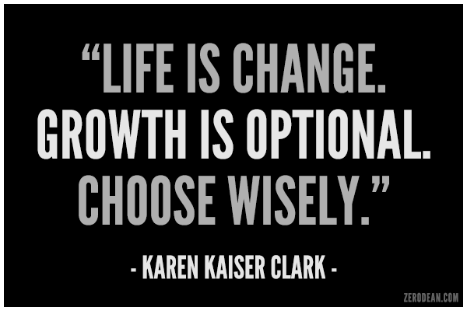

In with the New…
The backbone of any organization is its people. The employees who comprise the City of Houston’s workforce are the backbone of the fourth largest municipality in the United States. With growth comes pain; the City of Houston has experienced pain relative to its rapid expansion and the relative encumbrances while accomplishing critical missions, sustaining daily life and business within the city, and maintaining its workforce.
As the above quote by Karen Kaiser Clark suggests, make wise choices. The City of Houston has chosen wisely in recognizing and addressing a need for change with respect to the way its employees are assessed, as well as recognizing a need for a better way for supervisors and managers to communicate with their employees.
The need for change ushered in the idea of HEAR in the summer of 2012, followed by the development of training and associated materials rolling out across the city during the fall of 2012 and continuing on to present. Additionally, the need to close out ‘old business’ – old work plans and assessments, were a matter that had to be addressed immediately.
The majority of supervisors and managers, reviewing authorities, and other upper level management personnel were all people who had been in place long enough that most were familiar and comfortable with Performance Impact. In fact, the level of comfort may have even contributed to the failure of Performance Impact in that supervisors and managers could effectively ‘manage’ and ‘supervise’ from a distance with no real knowledge of their employees’ accomplishments, and then somehow conduct an annual assessment. The numbers could easily be manipulated in the favor of one employee over another; management really had no real reason to get to know their employees’ strengths and weaknesses because comments were pre-populated and could be used to address anyone in the most generic terms with no real justification. The result was an unbalanced approach to management; employees were not really compelled to do better because there was no real understanding of how to or where to get started, or whether there was a time associated with given tasks. All of this equaled a flawed method of doing business, and the city moved to correct it with HEAR.
The strengths of HEAR include transparency, simplicity, and accountability-up and down the chain of command. Ease of use is another strong point with HEAR. Gone are the days that an employee’s work plan would take half a ream of paper to print. With HEAR, while printing is still available, the volume of information required to create an effective work plan can be succinctly entered while still communicating what needs to be noted between employee and management. Better still, HEAR is available online 24-hours a day wherever there is internet access, enabling all parties to view, edit, sign-whatever needs to be done from the comfort of wherever they are and on whatever Internet-enabled device they may be using.
A great deal of resources were put into the development of HEAR and the interim product that is currently in use throughout the city. The format of HEAR necessitated that some of the nuances of Performance Impact either change or go away altogether. While that evolution was not without its own growing pains, the aforementioned ‘old business’ was concluded as planned, thus creating an opportunity, the right opportunity to continue the ushering in of a new way of doing things, specifically employee evaluations. The dawning of a new day is upon the City of Houston in the form of SMART Goals!
Earlier, the strengths of HEAR were mentioned as including transparency, simplicity, and accountability. To facilitate transparency, Administrative Procedure 3-20 (AP 3-20) includes instruction to managers and supervisors that they must meet with their employees no less than two times per year. The truth is there could be as few as four meetings per year documented between supervisor and employee to effect the changes in communication and performance as mandated by the AP 3-20, and to monitor progress discussed in the employee work plan.
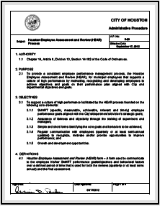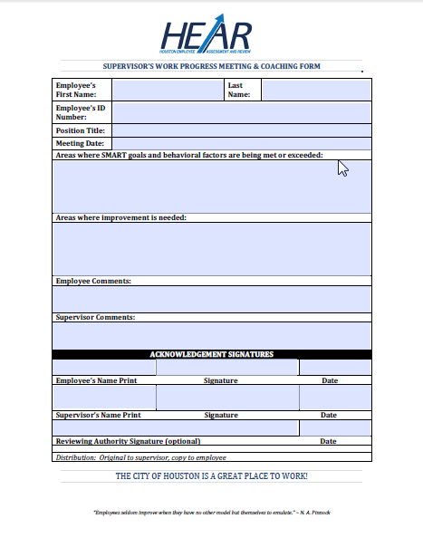
On the left, the AP 3-20; on the right, the HR Performance and Coaching Meeting Form

To address the need for transparency, the AP 3-20 mandates that supervisors and managers meet with their employees no less than twice per year, but preferably four times, totaling once per quarter. At these meetings, it would behoove management to document the meeting and make pertinent notes gleaned from the conversation with the employee. There is no mandate that meetings be held anywhere specifically or at any time in particular. However, as a suggestion only, engaging the employee in their workspace makes it easier for management to take note of the conditions of the employees’ work space, progress, and any equipment issues (as they apply). The one condition that should be maintained is right to privacy-meetings should not be open for public display. The manager might also ask the employee if it would be alright with him or her if note taking during the meeting would be acceptable. Once the meeting concludes, provide the employee with a copy of your notes so that both the manager and employee are on the same page and the risk of a he said-she said type of argument is nullified before ever taking place. This is transparency as it applies in a manager-employee relationship. There are no hidden agendas, a reduced chance of questions going unasked or unanswered, and the employee is rightfully given respective consideration to their concerns and career.
But what do these conversations have to do with SMART Goals? Simply stated, the work plan in place at any point during the year serves as a conversation starter between management and employee. Concerns, ideas, good points, failures – all and anything mentioned at these meetings and conversations between manager and employee should be noted and maintained. Why? Because this information can help the supervisors or managers develop new goals for both the accomplishment of their department’s goals and the enhancement of their employee’s career. How the employee fares, so fares the manager as the employee’s success is a mirror image of the supervisor’s ability to lead, manage, direct, supervise, all of the above. The notes taken during the work progress meeting will tell whether the SMART Goals are well-conceived and well-written, based on a historical perspective of the employees’ demonstrated ability to accomplish tasks, or are off the mark altogether. In either case, the results from the meeting are crucial to the construction of effective SMART Goals.
To address simplicity, analyzing the acronym SMART details for the supervisor or manager that what they come up with for goals needs to meet the single most important element of the equation, it must be smart. Accomplishing whatever the task is makes the employee look smart. The employee accomplishing what is expected of him makes the supervisor or manager look smart in their execution of delegation. The goals should be smart because it would be the opposite to ignore the idea that everyone has a hand in getting the department’s goals met!
Lastly, to accommodate accountability, the manager or supervisor is as responsible to the employee as the employee is to the manager or supervisor. Additionally, the reviewing authority has accountability in the process as well. The reviewing authority’s (RA) role in reviewing the proposed work plan and subsequent assessment provides a level of accountability to the employee. If the RA deems that the SMART Goals are ambiguous, unrelated to the department or employees’ job, too aggressive, not aggressive enough, fail to get the department’s goals met, the obligation on their part is to reject the work plan or assessment and/or have it explained and/or changed.
The mayor’s expectation is that there is work place equality, that there are no favored employees, that there is effective communication occurring in all work places within the city. A properly written SMART Goal will be based on the department’s goals, and the employee’s history with the city and/or department and their related successes on the job. There should be no surprises, nothing unrelated to what the employee can accomplish or what the manager’s expectation of the employee should be. But what does that really look like? Refer back to the earlier example of how things looked:
Job Duty
Section Weight: 50%

Extra duties in direct support of the department
Due date:
Weight: 16%
Category: Leadership and Systems Thinking Skills
Description: Performs extra duties as assigned in support of the department
Measurement: Outstanding: Failure to comply with job function no more than one time
Strong: Failure to comply with job function no more than 2-3 times
Acceptable: Failure to comply with job function 4-5 times
Needs Improvement: Failure to comply with job function more than 5 times

Looking at nothing more than the language of the ‘Job Duty’, the employee would have no idea what is really expected of him or her, but they are certain that 16% of what they are being assessed on daily and overall somehow relates to accomplishing extra duties. What’s more, when the time comes to assess the employee’s performance, the manager or supervisor will somehow have to calculate whether the employee truly utilized 16% of their work time to accomplish the extra duties. Is there a ‘Roadmap to Success”, as described with the HEAR Application?
Looking at the HEAR Application and the requirements for utilizing SMART Goals:
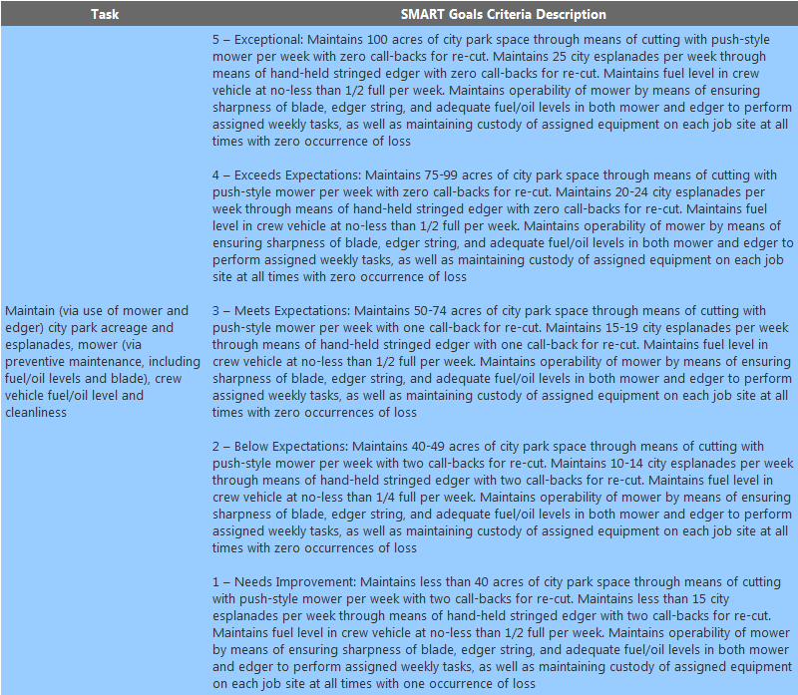
In this example, the manager has effectively created a SMART Goal; it includes the employee’s tasks (the maintenance of city park space and esplanades specifically, the tasks are measurable in that it is broken down in quantity and quality increments in the SMART Goals Criteria Description; i.e. 5 – Exceptional = 100 acres, etcetera, 4 – Exceeds Expectations = 95 – 99 acres, etcetera …), the tasks are attainable because the greenspace manicurist crews maintain records of what they have cut in the past and these can be easily and readily accessed to establish what each member of the crew (or each individual manicurist) is capable of contributing to his or her team, the tasks are absolutely relevant because they pertain specifically and exactly to what the individual does and with what he does it as it relates to greenspace manicuring, and lastly, they are time-based (or bound) in that the individual knows how much time (weekly) is allotted for each task. In some cases, each task may be daily, or by occurrence. In any case, there is a measure of time in which the individual has to complete their assigned task(s).
The above example is the entire purpose of SMART Goals; as Mayor Anise Parker said, “HEAR is designed to reduce the subjectivity of employee evaluations”. By utilizing SMART Goals that pertain to your employee and his or her contribution to the success of the department, employees will be used more effectively, and management should also be more effective as a result. The subjectivity that results from ambiguous job duties and cloudy direction is effectively reduced, if not altogether eliminated.

A common question has arisen since the inception and implementation of the HEAR Interim Application, “How do I create a SMART Goal for my employee, they do so much and I have too much to supervise”. A good beginning to SMART Goals is to consider the importance of your employee. Yes, each employee has their own individual importance to the accomplishment of the city’s goals. Otherwise, neither you nor your employee would be an employee.
Once you get the perspective of how important the employee is to your overall success and the success of the department, you can begin to isolate what that individual employee contributes. For example: the HEAR Project Team consisted of more than 25 team members who worked jointly to develop the HEAR Process and materials associated with providing the inevitable training. Eventually, the need for so many people on the team became less and many trainers and other team members returned to doing their normally assigned duties in their department(s). Eventually, there were just two to carry the project forth to the development of this class you find yourself in; the Project Manager (PM), and the Project Coordinator (PC).
Without a lengthy diatribe into what each provides to the ongoing implementation effort, assume that the PM does high-level reporting, approvals, things of that ilk while the PC provides administrative support, facilitates classes, creates and maintains offerings and assigns credit to learners who have completed modules of training. There are many more facets to each employee’s position with respect to the daily goings-on of HEAR. But for training purposes, those tasks have been reduced for sampling.
The PC is someone who has a set hourly schedule, but routinely shows up for work early and stays late. The PM has become accustomed to this reliability and constant presence, and has inadvertently come to depend on it. One day, an unexpected tragedy befalls the PC and the employee and a fateful call is placed to the PM that an extended leave of absence may be required to tend to the emergency. To the PM, this is unexpected and can have unforeseen consequences. In other words, the ‘go-to guy’, the ‘right-hand man’ has fallen, what is the PM to do?
The Project Manager gathers thoughts and quickly identifies what is felt to be the most important contribution to the departments’ success (or in this case, the HEAR Projects’ success) – training facilitation is identified as the most important aspect of the PC being absent that needs to be replaced. Once this first contribution has been identified, a SMART Goal can be built around it. For example, if the PC provides 10-hours of training per week in terms of HEAR training classes, a replacement with the time, availability, and effectiveness will need to be identified so that continuity is ensured and that the city’s workforce can continue to receive necessary training. What does that look like?
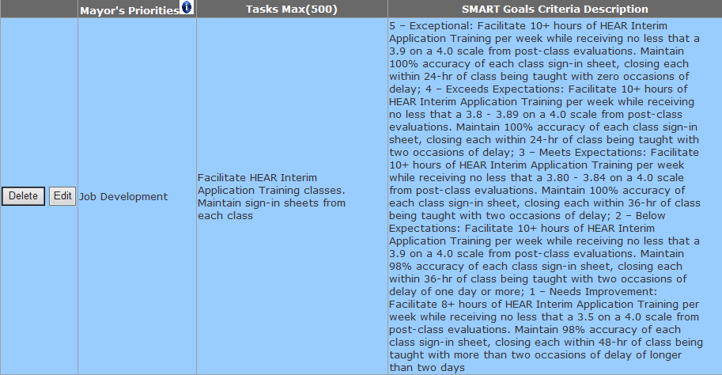
The PM identified what appeared to be the most impactful to the success of the HEAR Project, and then created a task built around that importance. Any person the PM identifies as a replacement or fill-in now has a clear idea communicated to him or her as to what is expected from them in their role. If there are several tasks that need to be identified by the PM, this can go on until the maximum of four SMART Goals is created.
This mindset can be applied to any employee by any manager in the city. It does require that the manager actually know who his direct reports are and what their strengths and weaknesses are as they apply to their jobs. What should have been noticed is that there is no team evaluation; HEAR is designed to create individual plans for individual employees. What one employee does well may not be what another does well. Thus, HEAR Work Plans should be created with the individual in mind, including his or her contribution to the overall success of their department(s).
And that is truly how simple it is to create a SMART Goal for City of Houston employees. Whatever it is that your employee does, whatever he or she was hired to do or accomplish, these things should not ever become lost or clouded because of a supervisor’s or manager’s desire to have a ‘go-to’ person. SMART Goals apply to everyone and should be created for only one employee at a time.
Remember, SMART Goals are the smartest way to get the most from your employees while providing them the SMARTest way to accomplish their own professional goals at the same time.

SMART GOAL WORKSHEET

When working on your smart goals please remember they must be:
Specific: Choose an actual task or responsibility to be performed by employee. The task/responsibility should be clear and easy to understand.
Measurable: You must choose the appropriate measurement for defining each employee’s task/responsibility.
Quantity: The number, rate, amount, margin, percentage, of the product or service that is expected to be accomplished when the employee performs the task.
Quality: The Characteristics of the task performed.
Time: The period, duration or term involving the task or responsibility.
Cost: The budget and financial allocations designed for the task or responsibility.
Achievable: Can this task/responsibility be accomplished or completed by the employee?
Ask the following questions:
- Does the employee have knowledge, experience, and skills for the task?
- Does the employee understand and know the planning and steps it takes to get the task done?
- Can the employee manage the scope of the task?
- Does the employee have the necessary resources for the task?
- Is the task realistic enough to attain success within the agreed upon time frame?
Relevant: Does the employee’s task/responsibility directly contribute to the mission/goals of the department and City of Houston.
Time-Based: There should be a clear timeframe, deadline, or other time-based expectations when the action, activity or behavior will take place.
Write out your smart goal and then read it and check off each category to make sure that you have met each requirement.

SMART GOAL WORKSHEET- EXAMPLE
When working on your smart goals please remember they must be:
Specific: Choose an actual task or responsibility to be performed by employee. The task/responsibility should be clear and easy to understand.
Performs intermediate traffic operational studies, makes recommendations, inputs data and produces analysis reports in a safe and efficient manner.
Measurable: You must choose the appropriate measurement for defining each employee’s task/responsibility.
Quantity - Must complete deadlines 80%-85% of the time.
Achievable: Can this task/responsibility be accomplished or completed by the employee?
Ask the following questions:
- Does the employee have knowledge, experience, and skills for the task? YES
- Does the employee understand and know the planning and steps it takes to get the task done? YES
- Can the employee manage the scope of the task? YES
- Does the employee have the necessary resources for the task? YES
- Is the task realistic enough to attain success within the agreed upon time frame? YES
Relevant: Does the employee’s task/responsibility directly contribute to the mission/goals of the department and City of Houston.
Yes, this job is relevant to the position and the goals of the department.

Time-Based: There should be a clear timeframe, deadline, or other time-based expectations when the action, activity or behavior will take place.

Meets deadlines during the rating period.

Your Smart Goal or Meets Expectations (3 rating) will read:

Performs intermediate traffic operational studies, makes recommendations, inputs data and produces analysis reports in a safe and efficient manner 80% to 85% of the time during the rating period.

RATING CRITERIA WORKSHEET- EXAMPLE

RATING CRITERIA:
EXCEPTIONAL (5) – Performs intermediate traffic operational studies, makes recommendations, inputs data and produces analysis reports in a safe and efficient manner 91%-100% of the time during the rating period;

EXCEEDS EXPECTATIONS (4) – Performs intermediate traffic operational studies, makes recommendations, inputs data and produces analysis reports in a safe and efficient manner 86% -90%of the time during the rating period;

MEETS EXPECTATIONS (3) – Performs intermediate traffic operational studies, makes recommendations, inputs data and produces analysis reports in a safe and efficient manner 80%-85% of the time during the rating period;

BELOW EXPECTATIONS (2) – Performs intermediate traffic operational studies, makes recommendations, inputs data and produces analysis reports in a safe and efficient manner 75%-79% of the time during the rating period;

NEEDS IMPROVEMENT (1) - Performs intermediate traffic operational studies, makes recommendations, inputs data and produces analysis reports in a safe and efficient manner below 75% of the time during the rating period.

DIVISION: ______________________________________________________________________________

BRANCH: ______________________________________________________________________________

SECTION/GROUP:_________________________________________________________________________
1. JOB TITLE: _____________________________________________________________________________
TASK: _________________________________________________________________________________
SMART GOAL:

RATING CRITERIA:
EXCEPTIONAL (5) –

EXCEEDS EXPECTATIONS (4) –

MEETS EXPECTATIONS (3) –

BELOW EXPECTATIONS (2) –

NEEDS IMPROVEMENT (1)-

2. JOB TITLE: _____________________________________________________________________________
TASK: _________________________________________________________________________________
SMART GOAL:

RATING CRITERIA:
EXCEPTIONAL (5) –

EXCEEDS EXPECTATIONS (4) –

MEETS EXPECTATIONS (3) –

BELOW EXPECTATIONS (2) –

NEEDS IMPROVEMENT (1)-

3. JOB TITLE: _____________________________________________________________________________
TASK: _________________________________________________________________________________
SMART GOAL:

RATING CRITERIA:
EXCEPTIONAL (5) –

EXCEEDS EXPECTATIONS (4) –

MEETS EXPECTATIONS (3) –

BELOW EXPECTATIONS (2) –

NEEDS IMPROVEMENT (1)-

4. JOB TITLE: _____________________________________________________________________________
TASK: _________________________________________________________________________________
SMART GOAL:

RATING CRITERIA:
EXCEPTIONAL (5) –

EXCEEDS EXPECTATIONS (4) –

MEETS EXPECTATIONS (3) –

BELOW EXPECTATIONS (2) –

NEEDS IMPROVEMENT (1)-

GENERAL BEHAVIORAL FACTORS (ALL EMPLOYEES)
Choose up to 4 critical general behavioral factors related to the position.

(1)

(2)

(3)

(4)

SUPERVISOR/MANAGER BEHAVIORAL FACTORS (SUPERVISORS & MANAGERS ONLY)

Choose up to 4 critical supervisor/manager behavioral factors related to the position.

(1)

(2)

(3)

(4)

