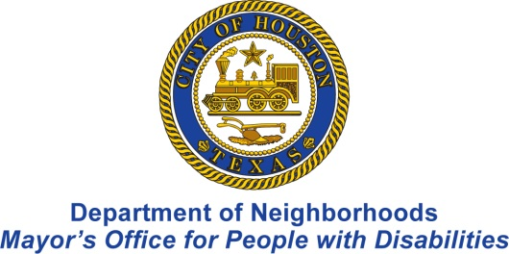

Free Tax Help & Preparation in Greater Houston
For People Who Are Deaf and Use American Sign Language
The Neighborhood Centers Free Tax Preparation Program and the Department of Neighborhoods Mayor’s Office for People with Disabilities are partnering again this year to provide free ASL interpreting by appointment to assist people who are deaf with the completion of their income tax returns. Interpreting services will be donated by Nightingale Interpreting Services.
Who Qualifies: Individuals and Families with Annual Income of Less than $58,000
When: Fridays and Saturdays from February 3 through March 25, 2017
Where: Registration required
Advance Registration Required
Interested persons must register a minimum of 48 hours in advance of the requested appointment date. Space is limited. Appointments will be scheduled on a first come, first served basis.
How to Register
To register, email Cristina Cave with Neighborhood Centers at ccave@neighborhood-centers.org or call the Department of Neighborhoods Mayor’s Office for People with Disabilities at 832-394-0814.
Bring Important Documents
Be sure to bring photo ID, social security cards of you and dependents or ITIN letters. For a list of the documents you will need, visit www.freetaxcenters.org. Click on the link “Checklist” to print the list.
