Application Date:
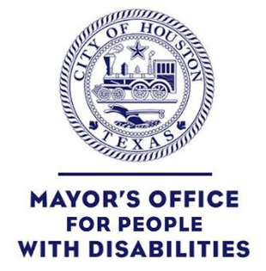
VISUAL FIRE ALARM PROGRAM
Mayor’s Office for People with Disabilities
1475 West Gray, Suite #180
Houston, TX 77019
We must have the original, completed signed documents back before you are considered for the free visual fire alarms. After you are registered for the fire alarm(s), someone from the Houston Fire Department (HFD) will contact you to arrange a date/time for installation of your fire alarm(s).

Citizen Contact Information
Last Name | First Name | Suffix
Street | City | State | Zip Code
Phone | Email
Demographic Information
Age | Gender | Ethnicity | Veteran
- Yes
- No
Mobility Assistive Device | Device Type | Hearing Assistive Device | Device Type
- Yes  - No |  | - Yes  - No
Primary Disability | Waiver Signed/Understood |  | Date sent to HFD
- Deaf  - Hard of hearing  - Autism | - Yes  - No
Primary Concern |  | Agencies/Organizations
FREE Visual Fire Alarm |  | Mayor’s Office for People with Disabilities  Houston Fire Department

Additional Concerns | Other | Referrals to Services | Agencies/Organizations
Comments:

